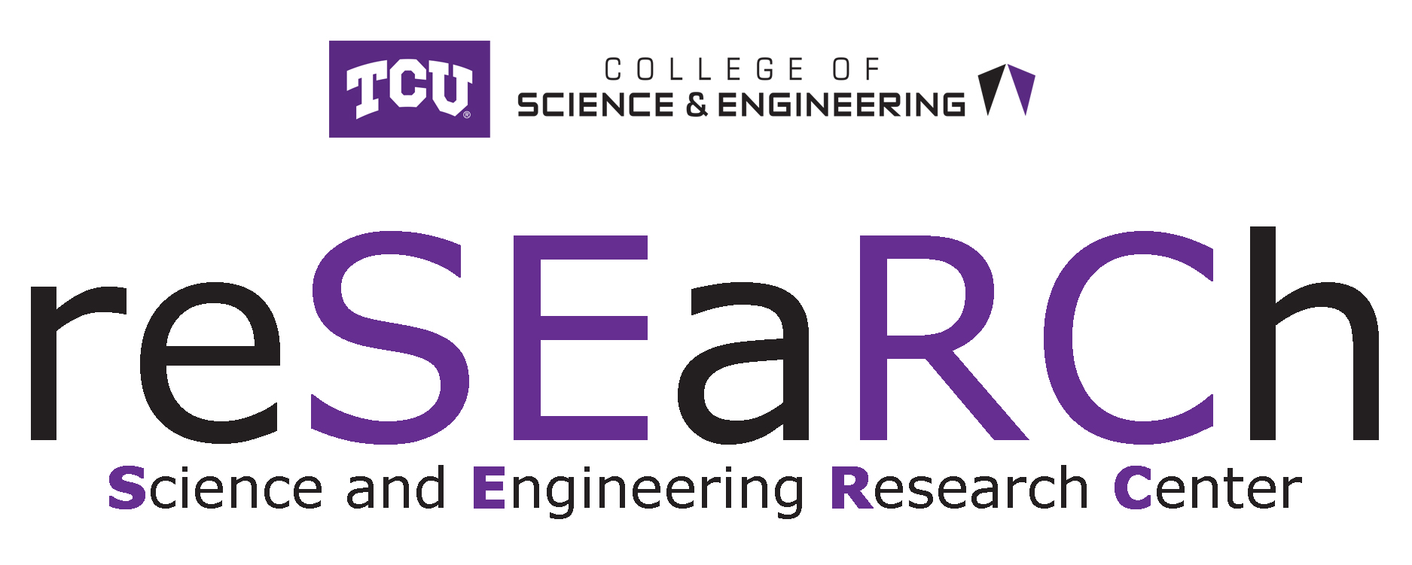
SERC Undergraduate Research Grant Program
Spring 2020 Application Round

This application covers research for the 2020–2021 academic year

Application Deadline: 4:00 pm, Friday April 24, 2020

GENERAL INFORMATION

The Science & Engineering Research Center (SERC) will be awarding research grants for the 2020 – 2021 academic year to undergraduate students engaged in research with faculty in the TCU College of Science & Engineering. Proposals from all academic departments in the College are welcome and encouraged.

The Fellowships
- Each fellowship will range from $500 to $1,500 depending on the indicated need of the research project.

Student Eligibility Requirements
- Student must have junior or senior standing with an anticipated graduation in May 2021, or later (exceptions can be made to include well qualified sophomore students upon the recommendation of the Faculty mentor). Student must have a minimum GPA of 2.5 in Mathematics and Science courses at TCU.
- If the student applicant had a previous project funded by a SERC grant, they must have presented the results of that project at a College of Science & Engineering Student Research Symposium (SRS).

Expectations

The grant period begins June 1, 2020 and expires April 30, 2021.

Note: Purchase Order requests accepted up to April 1, 2021; Invoices and reimbursement requests accepted only to April 30, 2021.
- Grant recipients are required to present a poster describing their research at the College of Science & Engineering SRS, during, or in the year immediately following, the grant period.
- Grant recipients are required to submit a one-page summary (a brief description of the project and the main results) no later than May 7, 2021 (end of Spring 2021 semester). The summary should include a layman’s introduction and be emailed to s.dolce@tcu.edu.)

Evaluation Criteria
Proposals will be reviewed by members of the SERC steering committee. The proposal is evaluated based on the following criteria:

Project Criteria:
- Clarity of the project description
- Appropriateness of the approach and/or method
- Broad impact statement
- Details of budget request
- Likelihood of a successful outcome

Student Criteria:
- Overall academic performance (as indicated by coursework and GPA)
- Recommendation letter from the faculty mentor
- Success of possible previous SERC grant (preference may be given to new SERC applicants)

Faculty Mentor Criteria:
- Mentoring plan

Undergraduate Research Grant Program
2020–2021 Granting period

APPLICATION FORM

Materials for each part (Parts A and B – see below) must each be separately submitted as a single PDF file via email to Sue Dolce, Assistant to the Dean (s.dolce@tcu.edu),
no later than 4 p.m. Friday, April 24 2020.
Award decisions will be made no later than Friday, May 1, 2020.
Applicants and Faculty mentors will be notified via email.

IMPORTANT NOTES:

- The application is to be submitted in two parts (see details below).
- The current format calls for the student to give a general description of the proposed research in Part A and the faculty member to provide a more detailed description as well as a broader impact statement in Part B.

  - PART A IS TO BE SUBMITTED BY THE STUDENT AS A SINGLE PDF FILE
  - PART B IS TO BE SUBMITTED BY THE FACULTY MENTOR AS A SINGLE PDF FILE
- Submit PDF files to Sue Dolce, Director of Degree Certification (s.dolce@tcu.edu).

COVER PAGE INFORMATION

Name of student(s)

Student email

Academic major

Expected date of graduation

Current overall GPA

Current math/science GPA

Faculty research mentor(s)

Faculty research mentor(s) email

Title of research project

List year(s) of previous SERC support & related SRS presentations (if any)

APPLICATION MATERIALS

PART A – STUDENT

To be completed and submitted by Student (or one of the students of a team)

- Describe your proposed research project or creative activity. The description should include an introduction targeting a lay audience. (Limit your narrative to 250 words or less). Also see below for information on the need to tie the narrative to your budget request.

- Describe the need and level of support that you are requesting. Be specific in providing information about what you need support for, e.g. number of items, cost per item. Your request should be tied to your narrative in that it should be clear to the SERC committee how items requested in the budget would be used in your project.

Provide an accurately calculated total for your requested budget. Note: Being able to present an accurate budget is deemed to be important by the evaluation committee. Please provide as much detail as possible. Avoid rounding off or asking for unspecified “supplies”. Present your budget in spreadsheet format.
(Examples of items that the grant can support: specific research materials and supplies; travel related to performing the research. Examples of items that the grant cannot support: travel to present research; stipends; computers (unless the computer resource is unique and not available at TCU).

- Submit an unofficial transcript of your academic record.

Student: Create a single PDF of all documents in the order listed above (1 – 3) and email to:
s.dolce@tcu.edu. (If you have trouble incorporating your unofficial transcript in the single PDF document, please just forward it separately.)

Note: Only the materials requested on this application form will be forwarded to the review committee.
____________________________________________________________________________________

PART B – FACULTY MENTOR

To be completed and submitted by Faculty mentor (or one of the faculty members if
several are involved in the project)

- Describe the approach/method, which will be used to carry out the proposed project or creative activity. Explain why this is a reasonable approach that should result in a high likelihood of a successful outcome. (Limit your narrative to 250 words or less).

- Describe the potential broader impact of the research (limit your description to 250 words or less), e.g. describe how the research may impact:
  - Integrating research and education,
  - Broadening participation of underrepresented groups,
  - Enhancing infrastructure for research and education,
  - Broad dissemination of scientific ideas and methods (general scientific literacy),
  - Direct benefit to society,
  - Increased partnerships between academia, industry, and other,
  - Improved national security,
  - Increased economic competitiveness of the U.S.
- Describe how you plan to mentor (support) the student throughout the proposed activity. Be specific as to how you will supervise your student's research progress (i.e. number of weekly meetings, reading assignments, lab time, activity milestones, etc.) (Limit your description to 250 words or less).

- Attach a signed letter of recommendation for your student.

Mentor: Create a single PDF of all documents in the order listed above (1 – 4) and email to:
s.dolce@tcu.edu.

Note: Only the materials requested on this application form will be forwarded to the review committee.

